DINA MITRANI GALLERY

FOR IMMEDIATE RELEASE:

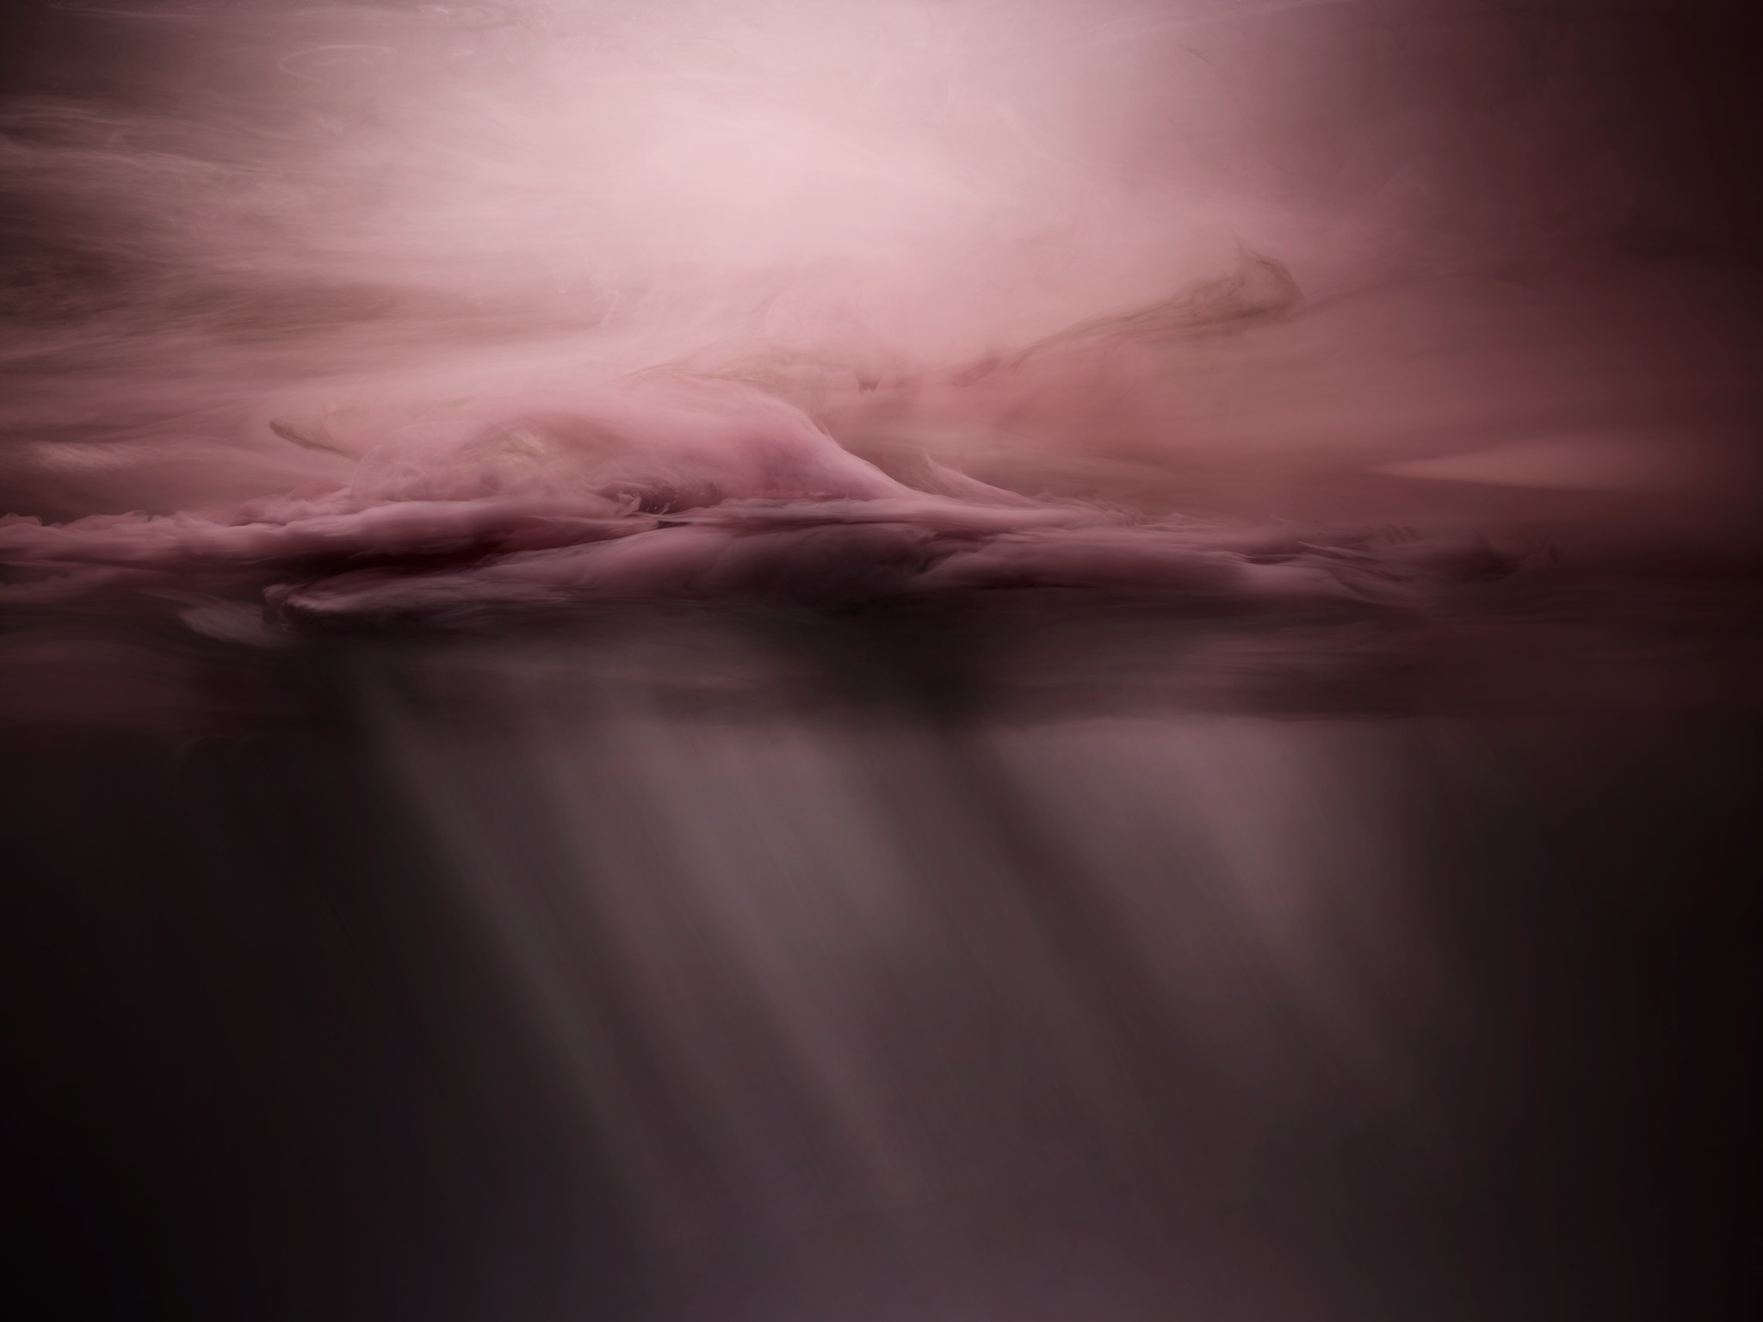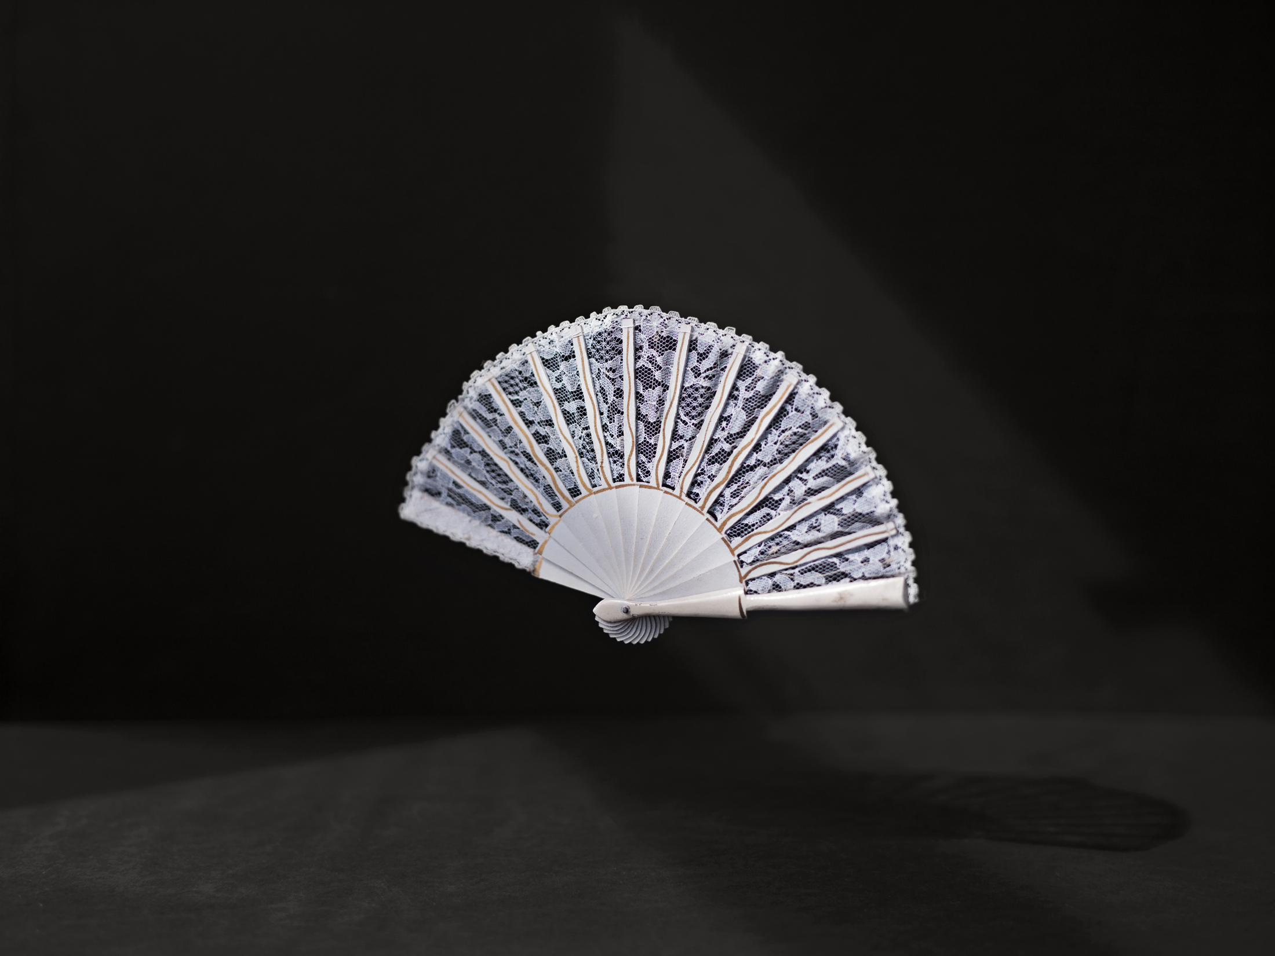

Phillip Toledano: When I Was Six

January 14 – February 27, 2015

Opening and Artist Talk: Thursday, January 14th at 7 pm

Dina Mitrani Gallery is pleased to present Phillip Toledano: When I Was Six, with an artist talk on Thursday, January 14th at 7pm. This is the artist’s first solo exhibition at the gallery.

When he was six, Toledano’s sister died in an accident. After her death, his parents rarely spoke of her, but she remained a constant presence in his life. In 2009, after his parents died, Toledano discovered a box full of his sister’s belongings -a secret museum of sorts, every object lovingly placed there by his mother. In choosing to open the box, he was able to rediscover his sister, while gaining a deeper understanding of his parents, and create this deeply personal work.

‘This work was a way of getting to know my sister. But it was also a way of getting to know my parents and their relationship with her. It gave me a glimpse into the pain and courage it took to stay together as husband and wife, as mother and father, to give me the beautiful life they gave me. I have no memories of my life after my sister’s death for a few years, other than an obsession with space, planets, and distant universes. I think that disappearing into those far away places was a way of saving myself.’

The work is shown in two parts. Still life images of childhood toys, family snapshots and memorabilia are illuminated by angular, natural light on black backgrounds. These almost forensic like photographs reveal the contents of the box and physical evidence of Claudia, her life, and her family. The skyscapes are abstract images of space - reimagined memories of a six year old when he needed saving.

Phillip Toledano was born in 1968 in London and has lived in New York for over 20 years. He deals with subjects that are firmly anchored in the inner landscape of everyday thoughts, but are often avoided, repressed, or completely blocked out. In his carefully and highly staged photographic series, Phillip Toledano deals with current issues that challenge us and often have a strongly confrontational effect. Whether conceptual, highly social commentaries or deeply personal and honest, Phillip Toledano is opening pathways, not only for other artists, but for people to communicate and express emotions that are often held within.

Toledano has published 7 photo books: When I Was Six, Maybe, The Reluctant Father, and A New Kind of Beauty by Dewi Lewis in England; Days with My Father by Chronicle, Phonesex and Bankrupt by Twin Palms. His work was recently in a retrospective exhibition at Deichtorhallen, Hamburg, Germany. He has had solo exhibitions in New York, Paris, Australia, Belgium, The Netherlands, Portugal and Italy. Toledano has also participated in group exhibitions internationally, and in important festivals, exhibiting and speaking about his work.

Dina Mitrani opened her Wynwood gallery in November 2008 specializing in international contemporary photography. The gallery represents emerging and mid-career artists, offers artist talks and lectures on photography as well as photo-based objects and books. The gallery is not only committed to promoting its artists, but also collaborating with other curators and photography dealers to bring museum quality exhibitions to the Miami community. The gallery aims to build and maintain relationships with museums, corporate institutions as well as the novice collector.

For more information, please visit www.dinamitranigallery.com

WYNWOOD ART DISTRICT
2620 NW 2 AVENUE MIAMI FL 33127
786 486 7248 dinamitrani@gmail.com
TUES – FRI, 1 – 5PM, SATURDAYS 12 - 4

